INDEX

Sl No | Name of the program | Date | Page No | Remarks
1 | Create your class time table using table tag. |  | 2
2 | Design a web Page for your college containing description of courses, department, faculties, library etc. Using list tags, href tags and anchor tags. |  | 4
3 | Create your Resume using HTML.Use text,link,and lists |  | 6
4 | Create a webpage of a supermarket using (internal css) |  | 9
5 | Use inline CSS to format your resume created |  | 12
6 | Use external css to format your timetable created |  | 14
7 | Use all the CSS inline,internal,external to format the college webpage that you have created. |  | 16
8 | write an HTML program to create your college website for mobile devices |  | 18

Program 1
Create class time table using table tag.

Aim
Create a html page to display class time table.

Program

<!DOCTYPE html>
<html>
<head><title>Studentslogin</title></head>
<body>
<h4 align="center"><u>BCA 2nd Year TIME TABLE</u></H4>
<table align="center" border="1">
<tr>
<TH>Day</TH>
<th>Hour1</th>
<th>Hour 2</th>
<th>Hour 3</th>
<th>Hour 4</th>
<th>Hour 5</th>
</tr>
<tr>
<th>DAY 1</th>
<td>DS</TD>
<td>OS</TD>
<td>ENGLISH</TD>
<td>WEBLAB</TD>
<td>WEBLAB</TD>
</TR>

<tr>
<th>DAY 2</th>
<td>OS</TD>
<td>DS</TD>
<td>ENGLISH</TD>
<td>MATHS</TD>
<td>IC</TD>
</TR>

<tr>
<th>DAY 3</th>
<td>MATHS</TD>
<td>OS</TD>
<td>DS</TD>
<td>WEB LAB</TD>
<td>WEB LAB</TD>
</TR>

<tr>
<th>DAY 4</th>
<td>MATHS</TD>
<td>IC</TD>
<td>OS</TD>
<td>DS LAB</TD>
<td>DS LAB</TD>
</TR>

<tr>
<th>DAY 5</th>
<td>DS</TD>
<td>ENGLISH</TD>
<td>HINDI</TD>
<td>MATHS</TD>
<td>OS</TD>
</TR>

</table>
</BODY>
</HTMl>

Output
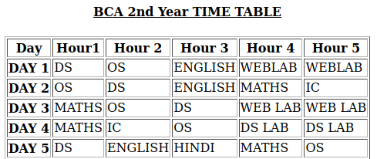

Program 2
Design a web Page for your college containing description of courses, department, faculties, library ect. Using list tags, href tags and anchor tags.

Aim
Design a web Page for your college containing description of courses, department, faculties, library etc. Using list tags, href tags and anchor tags.

Program

<!DOCTYPE html>
<html>
<head>
<meta name="viewport" content="width=device-width,initial-scale=1.0" />
<title>ST.George College Aruvithura</title>
</head>
<body>
<img src="/home/student/Downloads/sgcollege.jpg" height="480px" width="1310px">
<h4 align="center"><u>St.George College Aruvithura</u></h1>
<h3><strong><u>About</u></h3>
<p>St. George's College Aruvithura is a college under Mahatma Gandhi University, Kottayam. It is located in Aruvithura, Erattupetta, Kottayam District in Kerala, India. It was reaccredited with 'A++' Grade by NAAC for seven years in the fourth cycle.

St. George’s College Aruvithura, is a minority educational institution founded by St. George Forane Church, Aruvithura in 1965. Pioneered under the patronage of His Excellency Mar Sebastian Vayalil, the first Bishop of Pala, and cherished by a host of visionaries and philanthropists like Very Rev. Fr. Thomas Araythinal and Mr T. A. Thomman (Former Minister), the college, right from its inception, embarked on an odyssey towards academic pre-eminence. Very Rev. Fr. Thomas Manakkat, the founding manager and a great visionary, was truly instrumental in laying the foundations for a great beginning and Very Rev. Fr. Jacob Thazhathel, who followed him, was equally adept and insightful in his ideals, guiding the college during the early stages of its growth. For more than two decades, His Excellency Mar Joseph Pallickaparampil, the Bishop of Pala, had been the patron of the college. His Excellency Mar Joseph Kallarangattu is the present patron of this seat of learning.

Currently, the college offers 17 undergraduate courses, and 5 postgraduate courses and the Department of Chemistry and Physics are recognized Research Centers under MG University.</P>
<h3 align="left">Departments</h3>

<ul>
<li><a href="BCA.html">Department of Computer Application</a></li>
<li><a href="Bcom.html">Department of Commerce</a></li>
<li><a href="chemistry.html">Department of Chemistry</a></li>
<li><a href="EA.html">Department of English</a></li>
<li><a href="food.html">Department of Food science and technology</a></li>
<li><a href="maths.html">Department of Mathematics</a></li>
</ul>
Here is the library
<a href="library.html">library</a>
</body>
</html>

Output
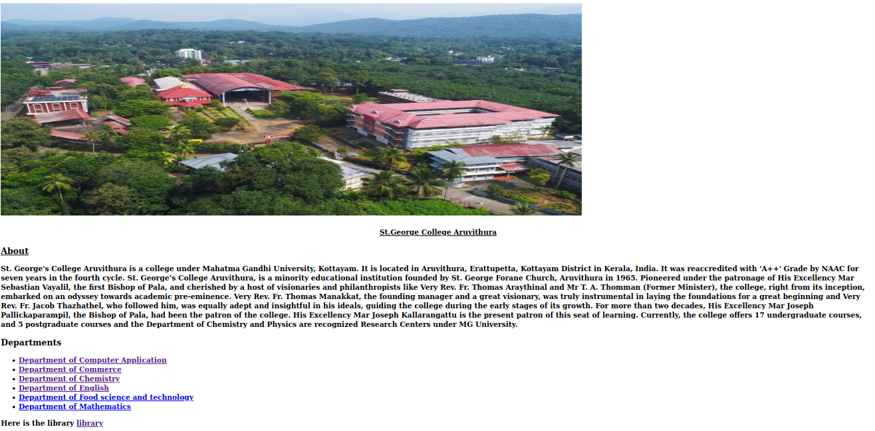

Program 3
Create your Resume using HTML use text.
Aim
Create Your Resume using HTML use text,link and lists
Program

<!DOCTYPE html>
<html>
<head><title> Resume</title>
</head>
<h1 align="center"> Resume</h1>
</body>
<H2><u>Personal Details</u></H2>
<b>Name:</b>Vijay Krishnan ES
<b>Email:</b>vijaykrishnan356@gmail.com<br>
<b>phone:</b>+918848445515<br>
<b>Address:</b>Manaakal(H) Ponkunnam (P.O)<br>
Kottayam,Kerela<BR>
<h2><u>Career Objective</u></h2>
Motivated BCA student seeking to improve the programing and problem solving skills in the IT field
<h3><u>Education</u></h3>
<ul>
<li><u>Degree:</u></li>
College:ST.George College Aruvithura(2025-29)
Course:BCA 4year
specialisation:Data science with FullStack Development
</uL>
<ul>
<li><u>Higher Secondary</u></li>
School:ST.Thomas Hss Erumely
Course:Computer Science
</ul>
<h3><u>Skills</u></h3>
<ul>
<li>Programming languages:C,javascript,Python</li>
<li>WebTechnologies:Html,css,javascript</li>
<li>Communication Skills</li>
</ul>
<h2><u>Language Communication</u></h2>
<ul>
<li>ENGLISH:Read,Write,Speak</li>
<li>Hindi:Read,Write,Speak</li>
<li>Malayalam:Read,Write,Speak</li>
<li>German:Read,Speak</li>
</ul>
<h2>Projects</h2>
<ul>
<li>Simple Calculator using c</li>
</ul>
<h2>Certifications</h2>
<p>Completed Meta Back-end Developer(Beginner)</P>
<a href="https//www.Coursesera.org">Coursesera</a>
<h3>Hobbies</h3>
<ul>
<li>Reading Books</li>
<li>Playing Carroms</li>
</ul>
</body>
</html>
</html>
Output
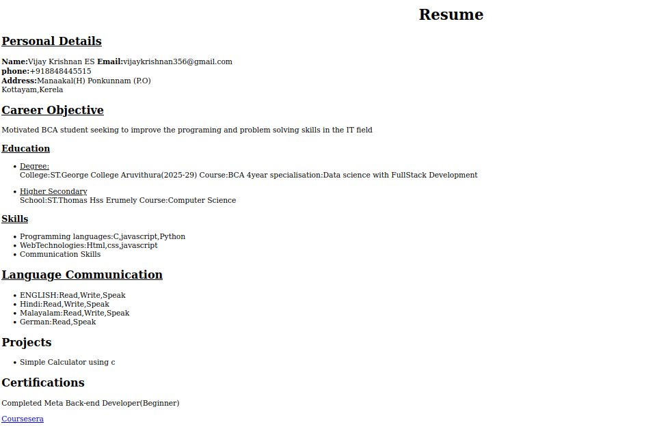


Program 4
Create a Web Page of a supermarket using(internal CSS).
Aim
Create a Web Page of a supermarket using internal CSS
Program
<!DOCTYPE html>
<html>
<head>
<title>marketOnline</title>
<style>
#ol{
color:green;
}
#fruit{
color:aqua;
}
#raw{
color:purple;
}
.veg{
color:red;
}
#dry{
color:black;
}

</style>
</head>
<body>
<h1 align="center"><img src="/home/student/vijay/weblab/Untitled.png" class="img-fluid"></h1>
<h1 align="center">Hypermarket</h1>
<ol id="ol">
<li>Fruits</li>
<ul id="fruit">
<li>Apple</li>
<li>Banana</li>
<ul id="raw">
<li>Ripe</li>
<li>Raw</li></ul>
<li>Orange</li>
<li>Mango</li>
<ul id="raw">
<li>Ripe</li>
<li>Raw</li>
</ul>
</ul>
<li>Vegetables</li>
<ul class="veg">
<li>Potato</li>
<li>Tomato</li>
<li>Onion</li>
</ul>
<li>Drinks</li>
<ul id="dry">
<li>Pepsi</li>
<li>Cococola</li>
<li>Sprite</li>
</ul>
</ol>
</body>
</html>
</head>

Output

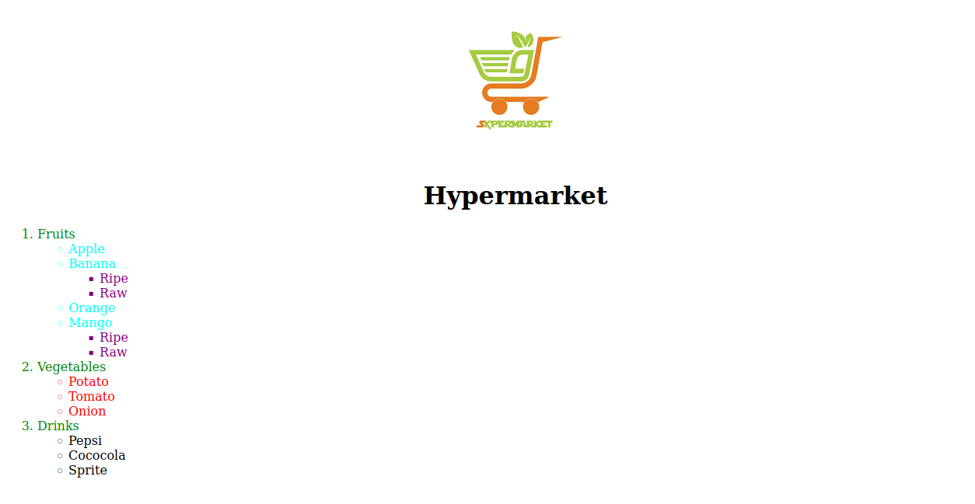

Program 5
Use Inline CSS to format your resume that you have created.

Aim
Use Inline CSS to format your resume that you have created.
Program

<!DOCTYPE html>
<html>
<div style="border:4px solid #00008B">
<head><title> Resume</title>
</head>
<h1 align="center"> Resume</h1>
</body>
<div style="border:2px solid blue">
<h2><u>Personal Details</u></h2>
<b>Name:</b>Vijay Krishnan ES
<b>Email:</b>vijaykrishnan356@gmail.com<br>
<b>phone:</b>+918848445515<br>
<b>Address:</b>Manaakal(H) Ponkunnam (P.O)<br>
Kottayam,Kerela<BR></div>
<h2 style="background-color:green"><u>Career Objective</u></h2>
Motivated BCA student seeking to improve the programing and problem solving skills in the IT field
<h3 style="background-color:red"><u>Education</u></h3>
<ul>
<li><u>Degree:</u></li>
College:ST.George College Aruvithura(2025-29)
Course:BCA 4year
specialisation:Data science with FullStack Development
</uL>
<ul>
<li><u>Higher Secondary</u></li>
School:ST.Thomas Hss Erumely
Course:Computer Science
</ul>
<h3 style="background-color:green"><u>Skills</u></h3>
<ul>
<li>Programming languages:C,javascript,Python</li>
<li>WebTechnologies:Html,css,javascript</li>
<li>Communication Skills</li>
</ul>
<h2 style="background-color:green"><u>Language Communication</u></h2>
<ul>
<li>ENGLISH:Read,Write,Speak</li>
<li>Hindi:Read,Write,Speak</li>
<li>Malayalam:Read,Write,Speak</li>
<li>German:Read,Speak</li>
</ul>
<h2 style="background-color:red">Projects</h2>
<ul>
<li>Simple Calculator using c</li>
</ul>
<h2 style="background-color:red">Certifications</h2>
<p>Completed Meta Back-end Developer(Beginner)</P>
<a href="https//www.Coursesera.org">Coursesera</a>
<h3>Hobbies</h3>
<ul>
<li>Reading Books</li>
<li>Playing Carroms</li>
</ul>
</body>
</html>

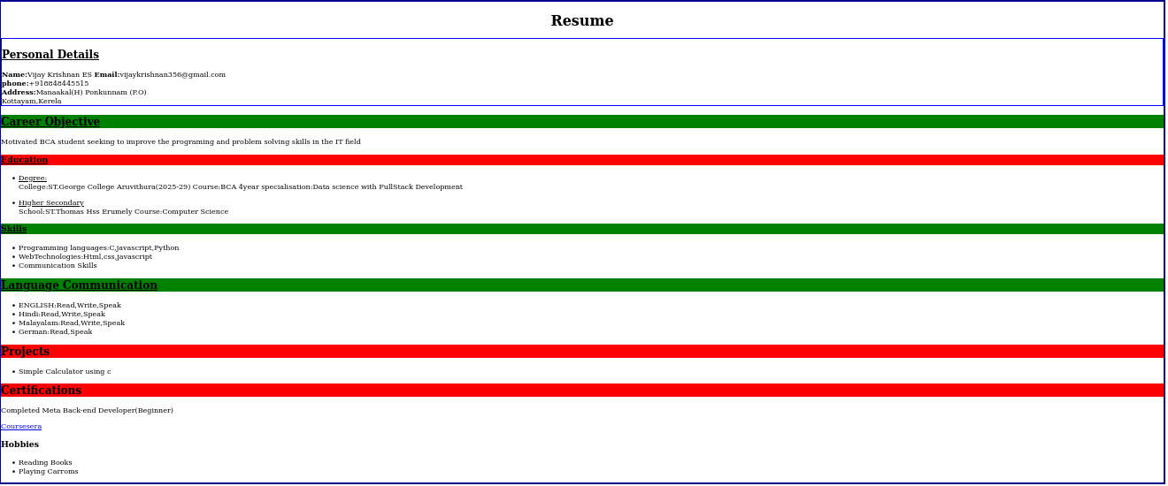
Output
Program 6
Use external CSS to format your time table created.

Aim
Use external CSS to format your time table created.
Program
<!DOCTYPE html>
<html>
<head><title>Studentslogin</title></head>
<link rel="stylesheet" href="styles.css">
<body>
<h4 align="center"><u>BCA 2nd Year TIME TABLE</u></H4>
<table align="center" border="1">
<tr>
<TH>Day</TH>
<th>Hour1</th>
<th>Hour 2</th>
<th>Hour 3</th>
<th>Hour 4</th>
<th>Hour 5</th>
</tr>
<tr>
<th>DAY 1</th>
<td>DS</TD>
<td>OS</TD>
<td>ENGLISH</TD>
<td>WEBLAB</TD>
<td>WEBLAB</TD>
</TR>

<tr>
<th>DAY 2</th>
<td>OS</TD>
<td>DS</TD>
<td>ENGLISH</TD>
<td>MATHS</TD>
<td>IC</TD>
</TR>

<tr>
<th>DAY 3</th>
<td>MATHS</TD>
<td>OS</TD>
<td>DS</TD>
<td>WEB LAB</TD>
<td>WEB LAB</TD>
</TR>

<tr>
<th>DAY 4</th>
<td>MATHS</TD>
<td>IC</TD>
<td>OS</TD>
<td>DS LAB</TD>
<td>DS LAB</TD>
</TR>

<tr>
<th>DAY 5</th>
<td>DS</TD>
<td>ENGLISH</TD>
<td>HINDI</TD>
<td>MATHS</TD>
<td>OS</TD>
</TR>

</table>
</BODY>
</HTMl>

Output
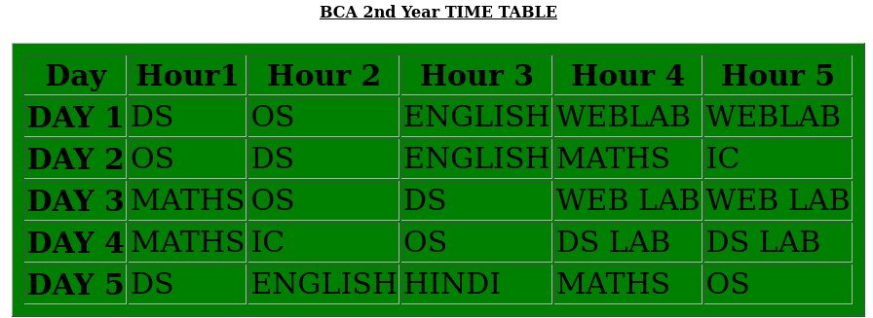

Program 7
Use all the CSS(inline,internal and external) to format the college web page that you have created.

Aim
Use all the CSS(inline,internal and external) to format the college web page that you have created.

Program
<!DOCTYPE html>
<html>
<head>
<meta name="viewport" content="width=device-width,initial-scale=1.0" />
<title>ST.George College Aruvithura</title>
<link rel="stylesheet" href="styleclg.css">
<style>
#cls{
background-color:#4b9996;
}

</style>
</head>
<body>
<img src="/home/student/Downloads/sgcollege.jpg" height="480px" width="1310px">
<h1 align="center" style="color:#0fb2f7"><u>St.George College Aruvithura</u></h1>
<h3><strong><u>About</u></h3>
<p>St. George's College Aruvithura is a college under Mahatma Gandhi University, Kottayam. It is located in Aruvithura, Erattupetta, Kottayam District in Kerala, India. It was reaccredited with 'A++' Grade by NAAC for seven years in the fourth cycle.

St. George’s College Aruvithura, is a minority educational institution founded by St. George Forane Church, Aruvithura in 1965. Pioneered under the patronage of His Excellency Mar Sebastian Vayalil, the first Bishop of Pala, and cherished by a host of visionaries and philanthropists like Very Rev. Fr. Thomas Araythinal and Mr T. A. Thomman (Former Minister), the college, right from its inception, embarked on an odyssey towards academic pre-eminence. Very Rev. Fr. Thomas Manakkat, the founding manager and a great visionary, was truly instrumental in laying the foundations for a great beginning and Very Rev. Fr. Jacob Thazhathel, who followed him, was equally adept and insightful in his ideals, guiding the college during the early stages of its growth. For more than two decades, His Excellency Mar Joseph Pallickaparampil, the Bishop of Pala, had been the patron of the college. His Excellency Mar Joseph Kallarangattu is the present patron of this seat of learning.

Currently, the college offers 17 undergraduate courses, and 5 postgraduate courses and the Department of Chemistry and Physics are recognized Research Centers under MG University.</P>
<h3 align="left">Departments</h3>

<ul id="cls">
<li><a href="BCA.html">Department of Computer Application</a></li>
<li><a href="Bcom.html">Department of Commerce</a></li>
<li><a href="chemistry.html">Department of Chemistry</a></li>
<li><a href="EA.html">Department of English</a></li>
<li><a href="food.html">Department of Food science and technology</a></li>
<li><a href="maths.html">Department of Mathematics</a></li>
</ul>
Here is the library
<a href="library.html">library</a>
</body>
</html>

Output
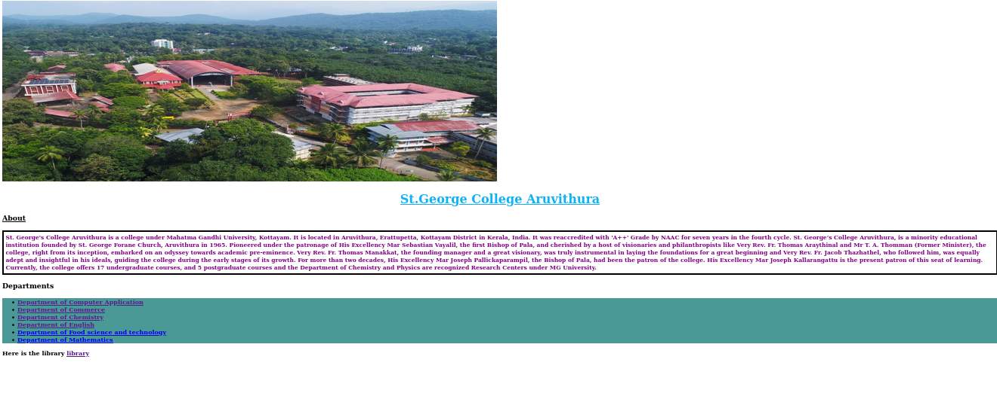

Program 8
Write a HTML Program to create your college website for mobile device.
Aim
Write a HTML Program to create your college website for mobile device.
Program
<!DOCTYPE html>
<html>
<head>
<meta name="viewport" content="width=device-width,initial-scale=1.0" />
<title>ST.George College Aruvithura</title>
<link rel="stylesheet" href="styleclg.css">
<style>
#cls{
background-color:#4b9996;
}

</style>
</head>
<body>
<img src="" height="480px" width="1310px">
<h1 align="center" style="color:#0fb2f7"><u>St.George College Aruvithura</u></h1>
<h3><strong><u>About</u></h3>
<p>St. George's College Aruvithura is a college under Mahatma Gandhi University, Kottayam. It is located in Aruvithura, Erattupetta, Kottayam District in Kerala, India. It was reaccredited with 'A++' Grade by NAAC for seven years in the fourth cycle.

St. George’s College Aruvithura, is a minority educational institution founded by St. George Forane Church, Aruvithura in 1965. Pioneered under the patronage of His Excellency Mar Sebastian Vayalil, the first Bishop of Pala, and cherished by a host of visionaries and philanthropists like Very Rev. Fr. Thomas Araythinal and Mr T. A. Thomman (Former Minister), the college, right from its inception, embarked on an odyssey towards academic pre-eminence. Very Rev. Fr. Thomas Manakkat, the founding manager and a great visionary, was truly instrumental in laying the foundations for a great beginning and Very Rev. Fr. Jacob Thazhathel, who followed him, was equally adept and insightful in his ideals, guiding the college during the early stages of its growth. For more than two decades, His Excellency Mar Joseph Pallickaparampil, the Bishop of Pala, had been the patron of the college. His Excellency Mar Joseph Kallarangattu is the present patron of this seat of learning.

Currently, the college offers 17 undergraduate courses, and 5 postgraduate courses and the Department of Chemistry and Physics are recognized Research Centers under MG University.</P>
<h3 align="left">Departments</h3>

<ul id="cls">
<li><a href="BCA.html">Department of Computer Application</a></li>
<li><a href="Bcom.html">Department of Commerce</a></li>
<li><a href="chemistry.html">Department of Chemistry</a></li>
<li><a href="EA.html">Department of English</a></li>
<li><a href="food.html">Department of Food science and technology</a></li>
<li><a href="maths.html">Department of Mathematics</a></li>
</ul>
Here is the library
<a href="library.html">library</a>
</body>
</html>

Output
